

WEEKLY



STATUS REPORT

Business Requirements

1. Identifying High-Value Customers – Which customer segments (e.g., Businessmen, Retirees, Blue-collar workers) generate the most revenue?
2. Understanding Spending Behavior – What are the most common expenditure types (Bills, Entertainment, Fuel, Online, etc.)?
3. Revenue & Interest Optimization – How much revenue is generated from different customer categories, and where can interest income be improved?
4. Credit Card Category Performance – Which card type (Gold, Silver, Platinum) is most profitable?
5. Customer Satisfaction & Retention – How do satisfaction scores correlate with spending behavior and transaction volume?
6. Growth Trends & Forecasting – Are credit card transactions increasing over time, and how do they vary by quarter?

# Project Objective

To develop a comprehensive credit card weekly dashboard that provides real-time insights into key performance metrics and trends, enabling stakeholders to monitor and analyze credit card operations effectively.



# Import data to SQL database

1. Prepare csv file 2. Create tables in SQL 3. import csv file into SQL

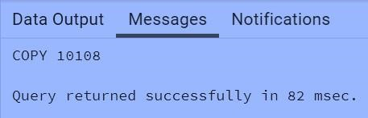

# Project Insights- Week 53 (31st Dec)

**WoW change:**



**Note:**



You can add more insights

* Revenue increased by 28.8%,
* Total Transaction Amt & Count increased by xx% & xx%
* Customer count increased by xx% **Overview YTD:**
* Overall revenue is 57M
* Total interest is 8M
* Total transaction amount is 46M
* Male customers are contributing more in revenue 31M, female 26M
* Blue & Silver credit card are contributing to 93% of overall transactions
* TX, NY & CA is contributing to 68%
* Overall Activation rate is 57.5%
* Overall Delinquent rate is 6.06%

 LinkedIn: [www.linkedin.com/in/nikitachaudhary001](http://www.linkedin.com/in/nikitachaudhary001/)[/](https://www.linkedin.com/in/rishabhnmishra/)